## Install Drive of Micro:bit Board

1. First of all, connect the micro:bit to your computer using a USB cable.

，then double-click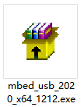to install.

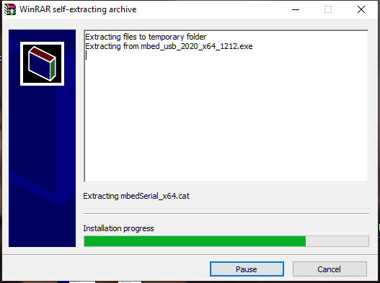

After downloading the driver, then click“Next”

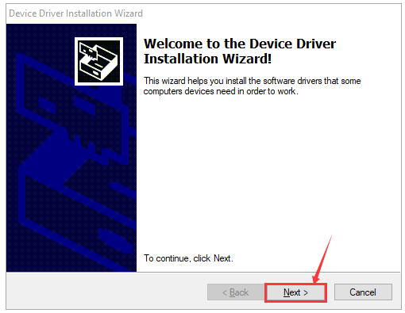

Click“Install”

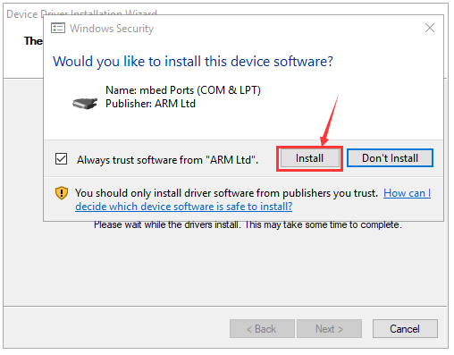

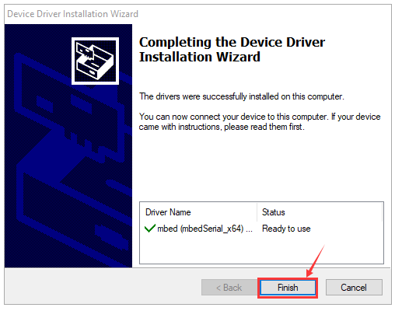

Tap“Finish”. Then click“Computer”—>“Properties”—>“Device manager”, as shown below.

